**Handling User Authentication-OUTPUT**

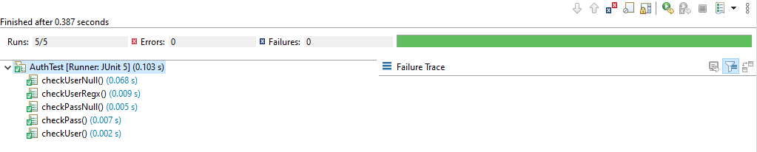

**If Wrong password is given, “checkPass” Test fails:**

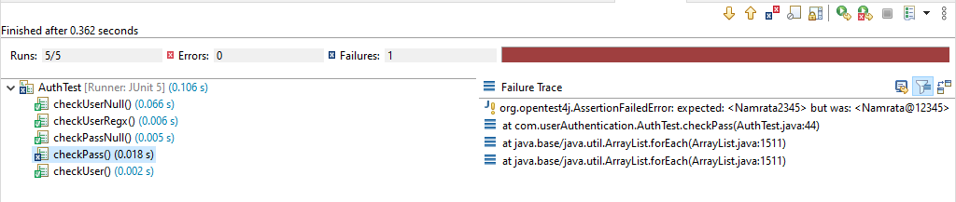

**If given email doesn’t match the with credentials, “checkUser” test fails:**

